SOP – Laser micromachined HAMMER Channels

(Asymmetric channel)

# Laser and Stage Trajectory

1. Open the Spyder application within Anaconda Navigator. This is the Python development interface.
2. Open the code “DGKA_HammerCode.py”  
   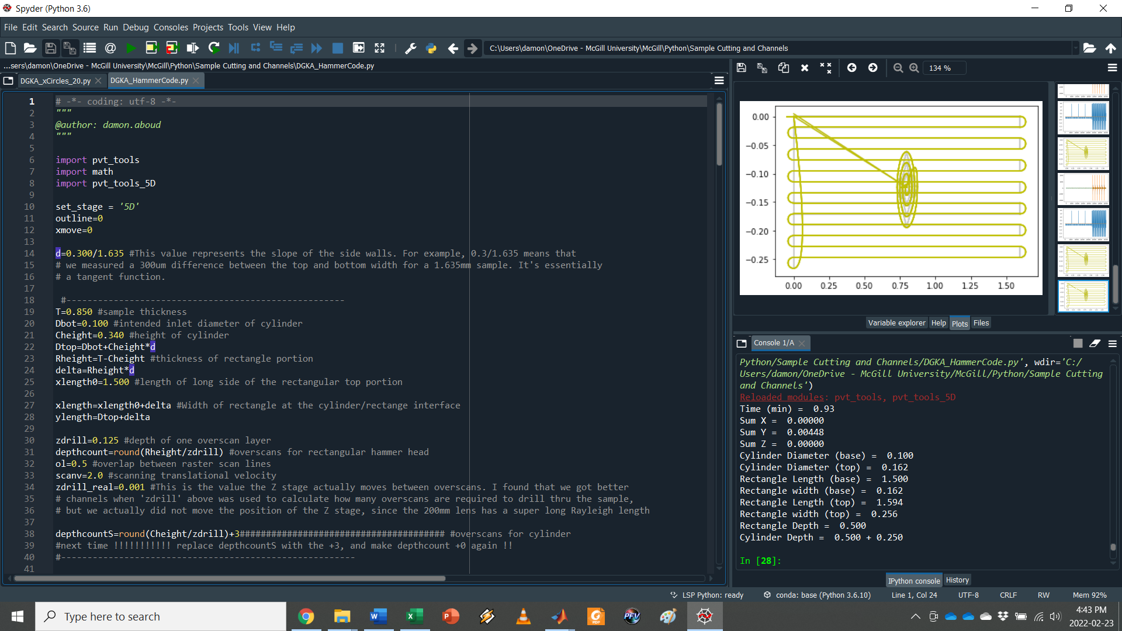
3. Check and adjust the values in lines 19-39 according to your intended channel size and experimental parameters. This is where you set values like the thickness of the sample and the dimensions of the hammer-shaped channel. It also includes laser micromachining parameters like the expected ablation depth per layer and scanning velocity. Those should mainly be left alone.
4. Run the code and check the outputs on the right. You should get a plot showing a rectangle with a spiral inside, which is a 2D representation of the hammer channel. Below you should also see the expected outcome of the channel, including the estimated time and the dimensions of the cylinder and rectangle.
   1. Note that those dimensions might not match exactly what you entered in step 3. This is because the ablation depth per layer depends on the laser settings. For example, if you remove 125 µm of material per scan, it is not possible to program a depth of 175 µm. The code just rounds things off to the nearest number of iterations and that’s the best you can do without finding new laser settings.
5. It’s not a bad idea to run the code through my Matlab program that gives a 3D visualization of the final channel shape and size:  
   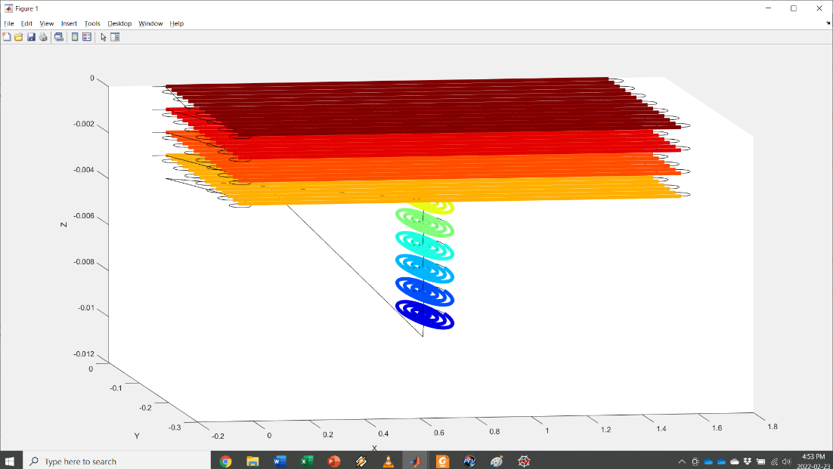
6. Here is a list of laser settings that Jin and I used:
   1. 1000 Hz rep rate
   2. Libra laser, 800 nm
   3. 2 mm/s scanning velocity
   4. 200 mm lens
   5. Expected overscan depth 125 µm
   6. Spot diameter 38 µm
   7. Overlap 50%
   8. Power 200 mW
7. Tape the sample to the stage with double sided tape.
8. Rock and roll.

# Materials

* Product name: Chemical-Resistant Slippery PTFE Sheets (1/32'', 24x24'')
* Catalog#: 9266k41
* Producer: McMaster-carr

# Optimized result (20211116)

* Laser setting:
  + Power 200mW
  + Z coordinate: at focal plane
  + PTFE thickness: 0.85mm
* Intended dimension

* Expected result

Minimize deviation from the dimensions marked in red (the main factors in deciding the droplet size)